Hotel Rwanda Questions
You must answer Questions #1-3 in complete sentences. Explain fully.
- What was the most powerful scene from the film? Describe the scene and explain why you chose it.
- Why didn’t the UN and the international community intervene? Does the UN and/or foreign nations have an obligation/responsibility to intervene during genocide?
- Why do you think Paul helped save thousands of lives during the genocide while others turned in their neighbors? In general, why do some people act courageously during genocide while others collaborate or turn a blind eye?
Choose ONE of the following to answer.
- What role did the media play during the genocide?
- Who is ultimately to blame for the genocide? Explain
- Imagine you are in charge of the UN tribunal after the genocide. How would you handle it? What would be a fair and ethical solution?

General Augustin Bizimungu: Evaded capture for 8 years, found in Angola, sentenced in 2011 to 30 years in jail
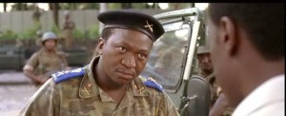
George Rutaganda: Arrested in 1995, sentenced to life in prison, killed in prison in Benin in 2010
